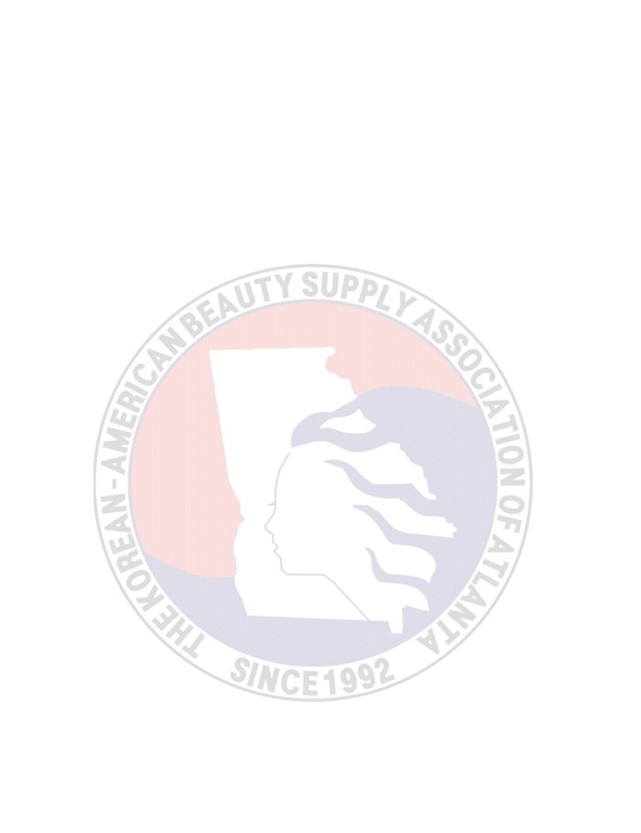
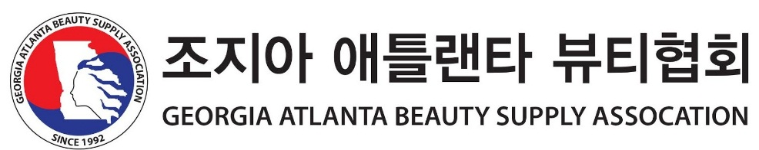

2019 Applying for Scholarship

.
Qualification :
1. Transcript
2. Community Service Part
3. Leadership Part
4. Sports or Art Part
5. Etc..
How many : 10
Award : Certificate & Cash Prize
Require Document
1. Application for Scholarship
2. A recommendation letter from School, Church, Organzation
3. A copy of School transcript
4. An Essay (My Life, My Dream)
5. Any award that won
How to apply : by mail : Georgia Atlanta Beauty Supply Association
5725 Buford Hwy. Suite #111, Doraville, GA 30340
or
by e-mail: atlbeautylife@gmail.com or Fax : 770-454-7977
Dead Line : Nov. 15. (Friday)
Notification : Dec. 6 (Friday)
Award : Dec. 15. 2019 (Sunday)

For further inquiry, please call at 770-454-7993 or e-mail atlbeautylife@gmail.com

Georgia Atlanta Beauty Supply Association
Chairman : Paul Son

The Korean American Scholarship Foundation 2019

Application for Scholarship

- Name(English):

Please attach your recent photo here
Last First Middle

(Korean if any):

- Reference Store Name:

Phone Number: ( ) -

- Current School name & address:
_________

- Permanent or home address:
_______________
Phone number: ( ) -

- E-mail :

- Date of birth :

- Place of birth:

- Sex: male ( )/ female ( )
- Status: US Citizen ( )/ Permanent resident ( )/ Student visa ( )
- List and briefly describe all distinctions, honors and award (including scholarship or grants) you’ve received:

- Please explain your Korean Heritage or ancestry:

- Currently you’re in school
- High school: Junior ( ) / Senior ( )
- College: Freshmen ( ) / Sophomore ( ) /Junior ( ) / Senior ( )
- Graduate: Master ( ) / Doctorate ( )
- Major:
- Degree:
- Expected date of graduation:
- GPA(on a scale): ( / )
- SAT or ACT score: Total ( ) / Date taken ( )
Math ( ) / Critical Redding ( ) /Writing ( ) / Science ( )
- Your plans upon graduation from college or graduate school:

- Education history
Names of all schools attended | City & State | Date of attendance | Degree(s) received
 |  | to
 |  | to
 |  | to
 |  | to

- List and briefly describe all extracurricular, civic, volunteer and community activities, special skills and hobbies:

- Have you previously received a GABSA (Georgia Atlanta Beauty Supply Association) scholarship? Yes ( )/ No ( ). If yes, your(s) received amount: $

Print Name: Date:

Signature:

5725 Buford Hwy. #111 Doraville, GA 30340 Tel.770-454-7993 Fax.770-454-7977
www.gabeautysupply.com atlbeautylife@gmail.com

